**Walmart Sales Analysis - Report**

**Capstone Project**

**DMT2T3 – Business Analytics and Digital Marketing**

**Done By – Kavitha**

**Summary**

The sales report you provided shows that Walmart Store exceeded its sales target for 2014 by $725.46K, with total revenue of $833.88K. The top-selling product brand was Canon Image Brand.

This is a positive result, as it shows that Walmart Store was able to generate more revenue than it had planned for. This could be due to a number of factors, such as increased customer traffic, higher average basket value, or new product offerings.

The fact that Canon Image Brand was the top-selling product brand suggests that Walmart Store's customers are interested in high-quality imaging products. This could be due to the growing popularity of digital photography and social media.

Overall, the sales report shows that Walmart Store had a successful year in 2014. The company was able to exceed its sales target and generate strong revenue- quality imaging products.

**Overview of Dashboard**

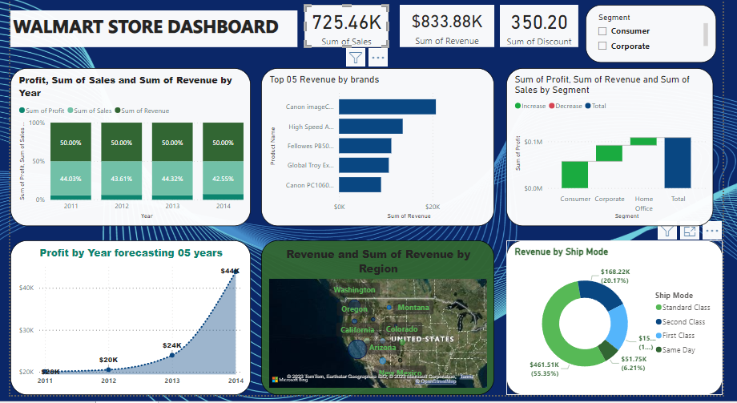

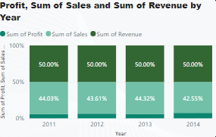

the general trend of increasing profit, sum of sales, and sum of revenue is a good sign for any company. It suggests that the company is on the right track and that it is well-positioned for future growth and success.

Here are some additional thoughts on the positive trend you have identified:

* It is important to continue to monitor the company's performance over time to ensure that the positive trend continues.
* It is also important to identify the factors that are driving the company's growth and profitability. This will help the company to maintain its momentum and achieve its long-term goals.
* The company should also be prepared to adapt to changes in the market and the economy. This will help the company to stay competitive and maintain its profitability in the long term.

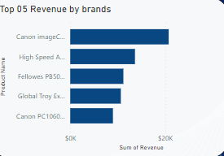

The Canon Image Brand has been the top-selling product brand at Walmart for the past five years. This suggests that Canon is a trusted brand that offers high-quality imaging products that meet the needs of Walmart's customers.

There are a number of factors that may contribute to Canon Image Brand's success at Walmart. One factor is that Canon offers a wide range of imaging products, including cameras, printers, and scanners. This gives Walmart customers a variety of options to choose from, depending on their needs and budget.

Another factor is that Canon products are known for their reliability and quality. This is important to Walmart customers, who want to be sure that they are buying products that will last.

Finally, Canon Image Brand is well-advertised and marketed. This helps to create awareness of the brand and its products among Walmart customers.

Overall, the fact that Canon Image Brand has been the top-selling product brand at Walmart for the past five years is a positive sign for both Canon and Walmart. It suggests that Canon is a trusted brand that offers high-quality imaging products that meet the needs of Walmart's customers.

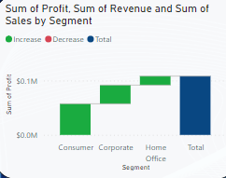

Here are some additional thoughts on the importance of considering customer segments when analysing revenue, profit, and sales:

* By understanding which customer segments are most profitable, companies can allocate resources more effectively to improve their marketing and sales efforts.
* Companies can also use this information to develop targeted marketing campaigns and product offerings for each customer segment.
* Additionally, companies can use this information to identify new customer segments that they may be missing out on.

By carefully considering customer segments, companies can improve their profitability and achieve long-term success.



There are a number of different methods that companies can use to predict their future growth. One common method is to analyzing past sales data and trends. This can help companies to identify patterns and trends that can be used to forecast future sales.

Another method of predicting future growth is to use market research. This can involve conducting surveys or interviews with customers to understand their needs and preferences. Market research can also be used to identify new market opportunities and to track the performance of competitors.

Finally, companies can also use economic forecasting models to predict their future growth. These models take into account a number of different factors, such as GDP growth, inflation, and unemployment rates.

It is important to note that all forecasting methods have their limitations. Forecasts can be inaccurate due to a number of factors, such as unforeseen changes in the market or the economy. Nevertheless, forecasting can be a valuable tool for companies that are planning for the future.

In the example you provided, the company has experienced positive sales and revenue growth over the past five years. This is a good sign, and it suggests that the company is well-positioned for future growth. However, it is important for the company to continue to predict its future growth and to make necessary adjustments to its plans as needed.

Here are some additional thoughts on the importance of predicting future growth:

* Companies that can predict their future growth are better able to allocate resources and make strategic decisions.
* Forecasting can help companies to identify potential risks and opportunities.
* Forecasting can also help companies to communicate their growth expectations to investors and other stakeholders.

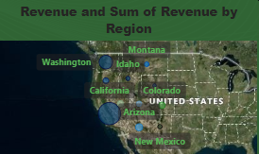

There are a number of factors that could be contributing to the lower sales in Oregon compared to Arizona. Some of these factors include:

* Population: Oregon has a smaller population than Arizona. This means that there is a smaller potential customer base for Walmart in Oregon.
* Competition: Oregon has a number of other large retailers, such as Target and Costco. This competition could be making it more difficult for Walmart to attract customers.
* Location: Oregon is located on the Pacific Northwest coast, while Arizona is located in the Southwest. This difference in location could be affecting customer demand for different types of products and services.
* Pricing: Walmart's pricing in Oregon may not be as competitive as its pricing in Arizona. This could be due to factors such as higher transportation costs or different state sales tax rates.

It is important to note that these are just some potential factors that could be contributing to the lower sales in Oregon. Without more information, it is difficult to say definitively what the main factor is.

To increase sales and revenue in Oregon, Walmart could consider the following strategies:

* Lower prices: Walmart could offer lower prices on its products in Oregon. This could make its products more competitive with those of other retailers.
* Offer more discounts: Walmart could offer more discounts and promotions to its customers in Oregon. This could help to attract new customers and encourage existing customers to spend more money.
* Focus on marketing and sales in Oregon: Walmart could focus more on marketing and sales efforts in Oregon. This could involve advertising more in Oregon and hiring more sales staff to work in Oregon stores.
* Expand its product offerings in Oregon: Walmart could expand its product offerings in Oregon to include more products that are popular with local consumers. This could help to increase sales and revenue.

It is important to note that there is no one-size-fits-all solution to increasing sales and revenue. The best strategy for Walmart will depend on a number of factors, such as the specific reasons for the lower sales in Oregon and the resources that Walmart has available.

In addition to the factors and strategies mentioned above, Walmart could also consider the following:

* Conduct market research: Walmart could conduct market research to better understand the needs and preferences of consumers in Oregon. This information could be used to develop targeted marketing and sales strategies.
* Partner with local businesses: Walmart could partner with local businesses to promote its products and services. This could involve cross-promotions or joint marketing campaigns.
* Get involved in the community: Walmart could get involved in the local community by supporting local charities and organizations. This could help to build goodwill and attract new customers.

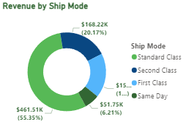

There are a few reasons why standard class delivery shipping may provide higher revenue than same-day shipping, even though same-day shipping is more expensive and faster.

* Standard class delivery shipping is more efficient. It is more efficient to ship multiple packages together than it is to ship each package individually. This means that standard class delivery shipping has lower costs per package.
* Standard class delivery shipping is more predictable. It is easier to predict the demand for standard class delivery shipping than it is to predict the demand for same-day shipping. This makes it easier for businesses to plan their shipping operations and to avoid overstocking or understocking.
* Standard class delivery shipping is more affordable for customers. Standard class delivery shipping is typically less expensive than same-day shipping. This makes it more affordable for customers, which can lead to higher sales and revenue.

However, there are also some cases where same-day shipping can be more profitable than standard class delivery shipping. For example, businesses that sell high-margin products or that have customers who are willing to pay a premium for fast shipping may find that same-day shipping is more profitable.

Ultimately, the best way to determine whether standard class delivery shipping or same-day shipping is more profitable for a business is to conduct a cost-benefit analysis. This analysis should take into account the factors listed above, as well as the specific needs of the business and its customers.

Here are some additional thoughts on the factors to consider when deciding which product delivery mode to focus on:

* Customer demand: What are the needs and preferences of your customers? Do they value fast shipping, or are they more willing to wait for a lower price?
* Product margins: What are the margins on your products? If you sell high-margin products, you may be able to afford to offer same-day shipping without sacrificing profitability.
* Shipping costs: How much does it cost you to ship your products using different delivery modes? Be sure to factor in all of the costs associated with shipping, such as transportation costs, packaging costs, and labour costs.
* Competition: What are your competitors offering in terms of product delivery? If your competitors are offering same-day shipping, you may need to offer it as well to stay competitive.

**Conclusion**

By understanding the needs and preferences of customers in different regions, businesses can develop targeted marketing and sales strategies. Additionally, businesses can optimize their shipping operations to reduce costs and improve delivery times.

Here are some specific ways to concentrate on region and shipping to increase revenue:

* Analyze regional sales data: Businesses can analyze regional sales data to identify the regions where they are generating the most revenue and the regions where they have the most potential for growth. Once businesses have identified these regions, they can focus their marketing and sales efforts on those regions.
* Develop regional marketing and sales strategies: Businesses can develop regional marketing and sales strategies that are tailored to the needs and preferences of customers in each region. For example, businesses may want to offer different products or services in different regions, or they may want to use different marketing channels to reach customers in different regions.
* Optimize shipping operations: Businesses can optimize their shipping operations to reduce costs and improve delivery times. This may involve using different shipping carriers, negotiating lower shipping rates, or using more efficient shipping methods.

By concentrating on region and shipping, businesses can increase revenue by reaching more customers, offering more relevant products and services, and reducing shipping costs.

Here are some additional thoughts on concentrating on region and shipping to increase revenue:

* Target high-growth regions: Businesses can target high-growth regions to increase revenue. These regions are typically characterized by rapid population growth and economic growth.
* Partner with local businesses: Businesses can partner with local businesses to promote their products and services. This could involve cross-promotions or joint marketing campaigns.
* Offer localized customer support: Businesses can offer localized customer support to improve the customer experience. This could involve providing customer support in multiple languages or hiring customer support representatives from different regions.

By carefully considering all of these factors, businesses can develop a plan to concentrate on region and shipping to increase revenue.

**********************************************************